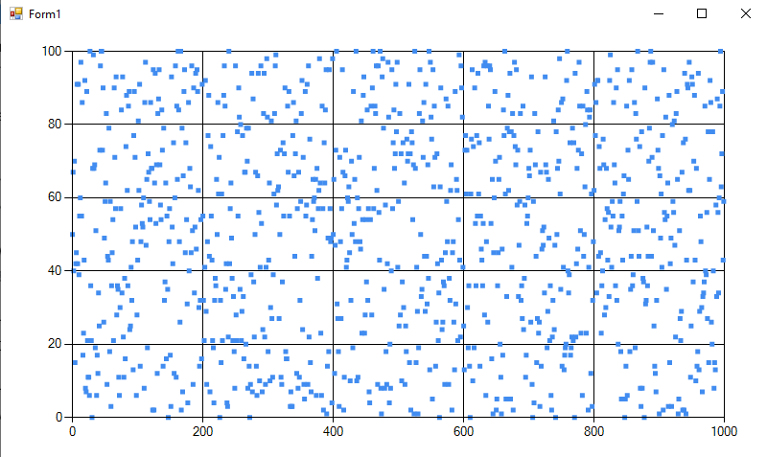

using System;

using System.Windows.Forms;

using System.Windows.Forms.DataVisualization.Charting;

namespace WindowsFormsApp1

{

    public partial class Form1 : Form

    {

        Random random = new Random();

        Chart chart1 = new Chart();

        public Form1()

        {

            InitializeComponent();

            chart1.Dock = DockStyle.Fill;

            Controls.Add(chart1);

            chart1.ChartAreas.Add(new ChartArea("Default"));

            chart1.ChartAreas["Default"].AxisX.Minimum = 0;

            chart1.ChartAreas["Default"].AxisX.Maximum = 1000;

            chart1.ChartAreas["Default"].AxisY.Minimum = 0;

            chart1.ChartAreas["Default"].AxisY.Maximum = 100;

            chart1.Series.Add(new Series("RandomNumbers"));

            chart1.Series["RandomNumbers"].ChartType = SeriesChartType.Point;

            GenerateRandomNumbers();

        }

        private void Form1_Load(object sender, EventArgs e)

        {

        }

        private void GenerateRandomNumbers()

        {

            for (int i = 0; i < 1000; i++)

            {

                int randomNumber = random.Next(101);

                chart1.Series["RandomNumbers"].Points.AddXY(i, randomNumber);

            }

        }

        private void button1_Click(object sender, EventArgs e)

        {

            chart1.Series["RandomNumbers"].Points.Clear();

            GenerateRandomNumbers();

        }

    }

}